Child in Need Policy and Procedures

Operational from: April 2020

Version Number: 1.2

Agreed by: CYPS Policies and Procedures Group

Responsible Service Area/Team: PD & QA Team

Review date: 24.10.2025
Document Summary
These procedures set out the requirements for agencies in Suffolk to work together to achieve good outcomes for children who are ‘in need’ under the Children Act 1989 and their families.

We will on request produce this policy, or particular parts of it, into other languages and formats, in order that everyone can use and comment upon its content.

Version Control | Reason for revision and summary of changes needed | Author | Date
1 | Redesign of Policy to streamline guidance and include signs of safety practice | Maureen Roscoe-Goulson | 22.12.2016
1.1 | Review and update terminology and links | Maureen Roscoe-Goulson | 10.04.2020
1.2 | Additional points for children who may have caring role on p5. Fathers and young people who become parents on p9. Review and update terminology and links | Maureen Roscoe-Goulson | 24.10.2023

Contents
- Scope of This Document 3
- Family’s Network Meeting (CIN) 4
- Child in Need Plans 5
- Reviews of Child in Need Plans 6
- Supervision Orders 8
- Visits to Children in Need 9
- Disabled Children and Children in Need Process 9
- Management Arrangements for Children in Need Service 9
- Flowchart for Family’s Network Meeting (in Assessment and CiN) 10

Child in Need: Assessments, Interventions, Plans and Reviews

Scope of This Document
These Procedures should be read in conjunction to the Suffolk Signs of Safety Practice Guidance, Practice guidance series on family-led practice, to take a whole family led approach and implemented in all Social Care teams, Children with Disabilities and Children in Care Teams.
This document does not apply to children who are the subject of a Child Protection Plan. See Transfer of Cases between Social Care and Early Help Teams (‘Step Up /Step
Down’). A child will usually have a service from a Social Care Team as a Child in Need
for at least three months after the ceasing of his/her Child Protection Plan.

Where resources are required to support the Child in Need plan (S.17) the necessary budget holder approval must be sought.

The Social Work Assessment reaches a decision about whether the child requires a service under Section 17 of the Children Act 1989. During the Assessment, members of the family’s network will be identified and involved if required in a Family’s Network Meeting (in assessment) to find out who can support the family. This could take place ahead of the first Family’s Network Meeting (CIN), be held within the Family’s Network Meeting (CIN) or following the Family’s Network Meeting (CIN). The overarching aim is to work in partnership with the family to identify safe people who can support any planning and change long term.

Each child within the same family will be allocated to the same Social Worker, following the one family one plan procedure; this also applies if children have shared residency and may spend part of the week in another household locally.

Family’s Network Meeting (CIN)
  - Family’s Network Meeting (CIN) will follow a Social Work Assessment where the assessment has concluded that a package of family support is required to meet the Child's needs under Section 17 of the Children Act 1989.

  - The Initial Family’s Network Meeting (CIN) should take place within 10 days of the Social Work Assessment decision that CIN support is required. This decision can be made at any point within the 45-day timescales for the Social Work Assessment and it is not necessary to wait until the conclusion of the 45 days.

  - The Family’s Network Meeting (CIN) provides an opportunity for a child and his or her parents/carers, together with key professionals, to identify and agree together the package of services required and to develop the Child in Need Plan.

  - The Plan should clearly explain the family member’s individual and joint responsibilities in terms of meeting the Plan’s goals, and the expectations in relation to their co-operation and behaviour.

  - All Family’s Network Meetings (CIN) should be attended by the child (depending on age and understanding), parents/carers, other key family members / key support network as appropriate, and those agencies whose potential/actual contribution is recommended as an outcome of an assessment. If the child does not wish to attend or it is not considered appropriate, the reasons for this should be recorded. The Social Worker must ensure that the child’s views are given to the meeting in a format acceptable to the child e.g., drawing, written, verbal.

  - The child's Social Worker should discuss potential attendees for the Family’s Network Meeting (CIN) with the child and the parents/carers prior to arrangements being made for the meeting.

  - It will be important that an appropriate venue suitable for the child and his or her family is used for the meeting. Consideration must be given to transport, timing, and any childcare issues. Where a child is attending a meeting and is of school age the meeting should be held outside of school time, wherever possible.

  - The meeting will be arranged and chaired by the allocated Social Worker who has carried out the most recent Social Work assessment. This is likely to be the Social Care Team, Children with Disabilities team or Child in Care team.

  - The child's Social Worker is responsible for convening the meeting and arranging invitations.

  - The Chair or another key professional will take a note of the meeting, recording the general areas of discussion, and the decisions and recommendations made, using

the relevant CIN planning or review forms (there is no need for separate minutes). These forms must be signed off by the Chair and the family as soon as possible and distributed to all participants.

  - The meeting should be chaired by the Social Worker or another key professional, this could be on a rotational basis as agreed by the group involved.

  - Equality and diversity issues and how the child’s needs will be met in these areas should be explicitly addressed as part of the meeting’s agenda. The child’s views and experiences will be gathered prior to the meeting and if the child is not attending, will be shared on their behalf by the Social Worker at the meeting. SOS tools to be used creatively with the child to help them express their views, feelings, and experiences.

Child in Need Plans
  - All children identified as a Child in Need following a Social Work Assessment, and who are provided with or require a continuous service coordinated by CYPS, will have a Child in Need plan. A Child in Need plan may be developed in a Family Network Meeting (CIN) where appropriate, in line with Section 1 Family’s Network Meeting.

  - Most Child in Need plans will be developed with the aim of achieving changes for the child so that Children's Services intervention will be time limited. However, some children and families may require longer term support, for example disabled children.

  - The Child in Need plan must identify any resources or services that will be needed to achieve the planned outcomes within the agreed timescales, who is responsible for which action and the timescale involved. Families should play a central role in this planning supported by key professionals.

  - The Child in Need plan should:
    - Describe the identified safety and well-being needs of the child, including those who may be young carers.
    - Include specific, measurable, achievable, child-focused safety goals intended to promote and safeguard the welfare of the child.
    - Include family’s ideas and build upon their suggestions.
    - Include child and family views.
    - Include realistic strategies and actions to achieve the planned outcomes.
    - Clearly identify the roles and responsibilities of professionals and family members, including the nature and frequency of contact by professionals with children and family members.
    - Include timescales that are not too short or unachievable but are realistic in

terms of allowing change to take place and to be tested.
    - Set points at which progress will be reviewed and how it will be reviewed,
i.e., measures to show the impact and effectiveness of social work interventions into the child’s and family life.
    - Include a bottom line - What CYPS say must be in place or must not happen to keep the child safe and well (non- negotiable).
    - Include a backup plan to be followed if circumstances change significantly and require prompt action or in the event of safety goals not being met.
    - Follow the Suffolk Safeguarding Partnership Procedures if there are concerns about significant harm to the child.

  - The Chair of the Family’s Network Meeting (CIN) is responsible for the distribution of the Child in Need plan. A copy of the Child in Need plan should be provided to the parents, child (depending on their age and understanding and using words and pictures) and the agencies or other key professionals involved in the provision of services under the plan, and the Children’s Guardian if the child is subject of Care Proceedings.

  - The Social Worker will be responsible for implementing the plan, including making referrals to appropriate agencies for services as described in the plan.

  - Where it becomes necessary to make minor adjustments to the plan and services provided, any changes to the plan must be made in consultation with the parents and the child (where appropriate) and key professionals from other agencies.

  - All Child in Need plans must be agreed by a Consultant Social Worker or the Social Care Practice Manager.

Reviews of Child in Need Plans
  - Child in Need plans must be reviewed by meeting between 8-12 weeks from the initial plan dependent on the existing level of concern. If there are significant changes in the family circumstances, an early review should take place.

  - Any Child Protection or safeguarding issues which arise during a Child in Need plan must be responded to in line with Working Together to Safeguard Children: A guide to inter-agency working to safeguard and promote the welfare of children.

  - The allocated Social Worker should chair the Family Network Meeting (CIN) review. The Practice Manager will have oversight of all CIN cases that have reached six months and twelve months’ duration and at that point the risk assessment of the case will be checked carefully and a professional judgement made about the progression of the case. It may be appropriate for the Consultant Social Worker to

chair the meeting if by the third review progression has not been made. No meetings should be chaired by a Family Support Practitioner. Children’s Family Support Practitioners can support within CIN cases, but not be case responsible.

  - Further reviews should take place between 8–12-week intervals, to be determined on a case by case basis. At 9 months, the plan should be reviewed carefully to identify if the CIN plan is likely to be concluded in 12 months. If this is not to be the case, then the case should be raised with the Social Care Practice Manager to see if Child Protection processes are required.

  - No child should remain subject to a CIN plan for over 12 months unless there are exceptional circumstances. For example- no recourse to public funds, families from abroad or children in long term residential schools. Review timescales of such cases should be determined on a case by case basis but in general be held at a minimum of 6 months or see below in relation to Supervision Orders (see Section 4 Supervision Orders).

  - A clear recorded rationale in case notes within the child’s electronic record.is required for any Family’s Network Meeting (CIN) review held outside the required timescale of between 8-12 weeks.

  - If a case is open more than 18 months, the Social Care Practice Manager will review the case in supervision with the Service Manager, who may attend the next planned review as required. Exceptions to this will be those cases where the plan acknowledges the need for longer term support, for example in relation to children who meet the criteria for the Disabled Children’s Team or No Recourse to Public Funds.

  - At each Family’s Network Meeting (CIN) Review:
    - The child’s Social Worker, who should invite or seek the views of the child, parents, and any service providers.
    - Equality and diversity issues and how the child’s needs will be met in these areas should be explicitly addressed as part of the meeting’s agenda.
    - The purpose is to assess whether the family’s goals have been achieved sufficiently to end involvement, reduce the level of input, or identify any changes in need that require addressing in a new plan.

  - All decisions made should be recorded on the child’s electronic record (LCS), together with reasons.

  - A copy of the record should be sent to the child (depending on age and understanding and using words and pictures if possible), parent and all other participants in the review process within ten working days from the meeting. The plan must be updated as required.

  - The outcome of a review will be:
- That the child is no longer a Child in Need requiring Social Care Services intervention, which will result in a recommendation by the Social Care Practice Manager or Consultant Social Worker that the case be closed. This may include a Stepping Down/Transfer to Early Help for further services. The child’s Social Worker must ensure that a lead professional takes responsibility before the case is closed;
- That the child continues to be a Child in Need requiring the same level of services, resulting in the continuing provision of services and minor amendment, as necessary, of the CIN plan.
- That the child’s needs are sufficiently complex and/or s/he requires additional services to safeguard and promote his or her welfare such as to justify an updating Social Work Assessment.
- That the child appears to be at risk of Significant Harm, resulting in the need for a Strategy Discussion/Meeting and possible Section 47 Enquiry and request for an Initial Child Protection Conference. Follow the Suffolk Safeguarding Children’s Board Procedures if there are concerns about significant harm to the child.

  - Where the outcome of the review is an amendment to the Child in Need plan, the Social Worker should circulate a copy of the amended plan to the child (depending on age and understanding using words and pictures), parents, and other agencies/professionals involved in providing the services set out in the amended plan, including any new services to be provided. The plan should also be sent to the Children’s Guardian if the child is subject of Care Proceedings.

Supervision Orders
  - Children who are subject of a Supervision Order are Children in Need and the processes in this chapter apply. The initial agreement should be drawn up as part of the Court Proceedings and should identify who should make the child available to the social worker, and how often and where the social worker should meet the child. There are likely to be other child specific parts of the agreement. The agreement should inform the CIN Plan. A review of the Initial Child in Need plan should be held no longer than 8 weeks later, and at least 8 weeks thereafter as with other CIN processes. At the point of the Family’s Network Meeting (CIN) review held at about nine months, a decision must be made by the Social Care Practice Manager whether to seek an extension of the Supervision Order for a further period, or to allow it to lapse.

  - Legal advice should be sought in this decision-making process and consideration given to a renewed application for Care Orders if appropriate. The actual usefulness of an extended Supervision Order should be considered in terms of the intervention into the family.

  - Children in Need who are subject to a Supervision Order will be allocated within the Social Care Teams or Disabled Children’s Teams.

  - In some Supervision Order cases it may be that a Child Protection plan is requested or required to be in place alongside the Supervision Order. In such cases the usual timescales for Child Protection visits and reviews will apply.

Visits to Children in Need
  - All children who are supported as Children in Need under s17 (Children Act 1989) will be visited with a minimum of every 20 working days. However, the frequency of visits should be dependent upon the needs of the child and family and will be more frequent with children where Child Protection plans have just ended or where concerns within CIN are running high, for example.

  - When planning visits, the following needs to be considered:
    - The frequency of visits is determined at the first Family’s Network Meeting (CIN), where the plan is determined and reviewed at Family’s Network Review Meeting (CIN).
    - Some visits must involve seeing the child alone (i.e., without the main parent or carer); unless the child is a baby, and this then may not be appropriate.
    - Visits can be both announced and unannounced.
    - Visits should have a defined purpose and impact and outcomes should be recorded in case notes on LCS after each visit.
    - Visits should include a parent who may not be part of the child’s household, particularly fathers, and that this may require a separate planned visit.
    - Young people who have become parents themselves may need additional contact/visits in their own right.
    - Be mindful that the plans are fluid and may require reviewing earlier than agreed previously at the initial Family’s Network Meeting (CIN).

Disabled Children and Children in Need Process

See Disabled Children Policy.

Management Arrangements for Children in Need Service
  - CIN cases in the Social Care teams are the overall responsibility of the Social Care Practice Manager. The Manager may or may not be the supervisor of the case; the case supervisor could be the Consultant Social Worker who will have oversight and responsibility for the management of the case. (Please refer to the Social Care Case Allocation Policy). The Consultant Social Worker will seek guidance and direction from the Social Care Practice Manager as necessary.

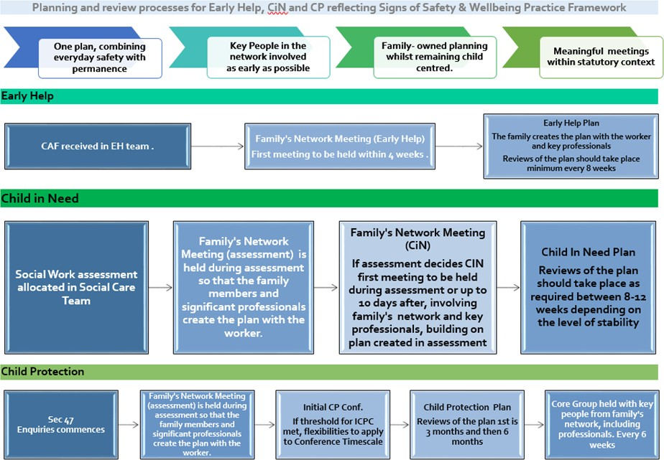
Flowchart for Family’s Network Meeting (in Assessment and CiN)

