**6 Progress/Impact**

Daniel was 4 months old when he was taken to Ipswich hospital by ambulance. He was unresponsive, floppy and pale. A CT scan identified that he had a fractured skull and bleed on the brain. The hospital suspected that he may have been violently shaken. He was transferred to Addenbrookes. They noted that he was cold, pale with intermittent twitching and an intermittent dropped heart rate. They also noted finger marks on his chest and further bruising across other parts of his body. At the Strategy Meeting, the consultant Paediatrician’s opinion was that the head injury was an inflicted and abusive injury.

**3**

**4 Key Practice Points**

**5 Learning and Actions**

**3 Key Lines of Enquiry**

**Daniel**

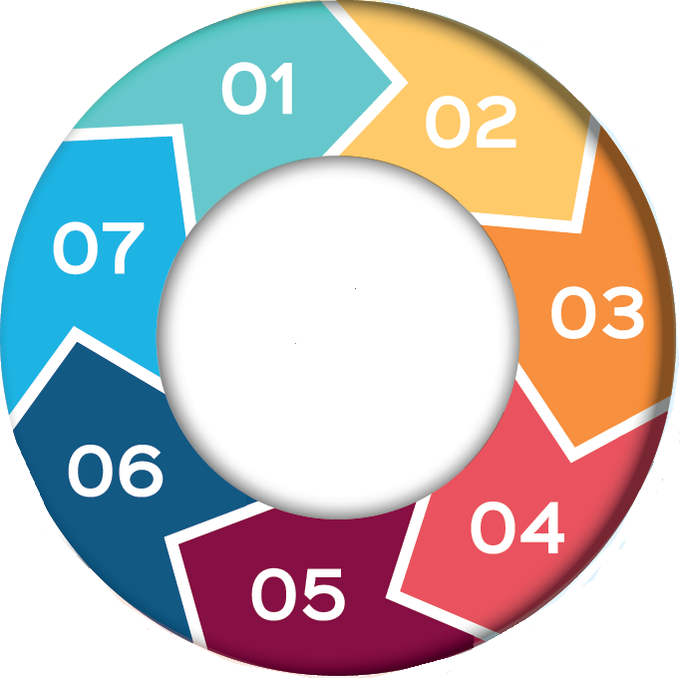

bAB

**1 Background and Concerns**

**2 Purpose of the Review**

-

The purpose of a Rapid Review is to share information and identify learning when a child has experienced serious harm (or death) as a result of abuse or neglect. The review considered the facts of the case and identified learning and whether any improvements in practice were required as a result.

Daniel is currently open to CYPS and is now the subject of an Interim Care Order. Very little was known about Daniel and his mother and her partner because they weren’t open to CYPS or known to the Police. There were some indications that mother’s partner was struggling with his mental health. There is no record of him accessing counselling. It was agreed that the case did not meet the threshold for a CSPR but that the learning would be incorporated into the SSP Working with Fathers/Partners Task and Finish Group.

* Good multi-agency working between Police, Social Care and Ipswich Hospital.
* There have been challenges obtaining information in written format from Addenbrookes Hospital about Daniel’s injuries. Police and CYPS have reported information blockages on previous occasions.
* There were indicators that Daniel’s father was struggling to cope although it is unlikely that any professional could have known about the level of risk to Daniel.

**Learning**

.

* SSP and Designated leads from all partners to take steps to ensure information from teams at Addenbrookes is shared with Suffolk agencies without delay.
* Suffolk to remain engaged in the rollout of the National ICON programme which focuses on preventing shaken babies.
* The SSP and partners to be aware of the findings from the National Panel’s report ‘The Myth of Invisible Men’ to better improve Suffolk partner’s responses/support to fathers/partners.

u

-

* The SSP’s independent Chair has spoken to Cambridgeshire regarding their experiences of information sharing with Addenbrookes. Cambridgeshire have confirmed they have no concerns or issues with Addenbrookes.
* ICON programme rollout in Suffolk is ongoing.
* The SSP has instigated a multi-agency working with fathers/partners Task and Finish group to improve Suffolk partner’s response/support to fathers/partners.

-

**7 Further Information**

* [Non-Mobile Infants](https://www.suffolksp.org.uk/non-mobile-infants#gsc.tab=0)
* [Neglect Resources](https://www.suffolksp.org.uk/neglect#gsc.tab=0)
* [Threshold Matrix and Guidance](https://www.suffolksp.org.uk/safeguarding-framework-and-threshold-matrix#threshold-document-and-guidance)
* [CSPR Panel The Myth of Invisible Men](chrome-extension://efaidnbmnnnibpcajpcglclefindmkaj/https:/static1.squarespace.com/static/62ea37b2f412d231ae2c2f35/t/644a7a6b576bf8021954e780/1682602605234/The_myth_of_invisible_men_safeguarding_children_under_1_from_non-accidental_injury_caused_by_male_carers.pdf)
* [Partnership Learning Conversations for Children's Services](https://suffolknet-my.sharepoint.com/personal/tracy_murphy_suffolksp_org_uk/Documents/Tracy%20Murphy/Seven%20Minute%20Briefings/Baby%20AB-F%207%20Minute%20Briefing.docx)

