Protocol for the Investigation of Child Abuse

Protocol between Suffolk Children and Young
People’s Services, Suffolk Constabulary and Health

Policy Version History

Version | Date | Review date | Author/Reviewer
6 |  |  | LSCB Adopted July 2004
7 | February 2010 | February 2013 | LSCB
8 | September 2017 | September 2020 | LSCB
9 | August 2020 | August 2023 | Maureen Roscoe-Goulson, PD&QA Team, SCC
9 | June 2021 | August 2023 | As above. SSP links updated by Sarah Dunne.
10 | July 2023 | August 2025 | Inge Nijkamp, WFD, SCC  Maureen Roscoe-Goulson, PD&QA Team, SCC

This protocol is produced on behalf of the Suffolk Safeguarding Partnership to satisfy the requirement of Working Together C3, Section 19, setting out how Section 47 enquiries and associated Police investigations should be conducted, and in particular, in what circumstances your enquiries are necessary and/or appropriate.

This protocol therefore focuses on the process of how and when Police and CYPS work together when undertaking Section 47 enquiries. Health and other partner agencies are referenced throughout in terms of their role in information sharing and supporting decision making. Links provided to the relevant protocols involving Health during Strategy threshold discussions/meetings and when the need for medical assessment may be required have been included for clarity.

Introduction

The investigation of allegations of child abuse is a crucial stage in protecting children. Although other agencies will be involved in aspects of the investigation process the Police and Children and Young Peoples Services (CYPS) are primarily responsible for the investigation. This Protocol is designed to help staff from the two agencies to work together. The Protocol will refer to the formal investigative interview, but detailed knowledge of
‘Achieving Best Evidence in Criminal Proceedings: Guidance on Interviewing Victims and
Witnesses, and Guidance on Using Special Measure (2022) (‘ABE’) is a requirement for
investigating officers.

Although ABE is a practice guide for investigative interviews in the context of a possible criminal prosecution, the final outcome of the interview will not be known at the time. It should not be automatically assumed that every investigative interview would be recorded on DVD.

If there is no possibility of criminal proceedings, a DVD interview should not be undertaken. (Case law (D v B and Others (Flawed Sexual Abuse Enquiry) (2006)) has established that even if a DVD interview is not appropriate, if there may be court proceedings under the Children Act 1989 – whether private or public law – there should still be a forensic interview following the ABE principles for interviewing young children.)

This Protocol offers an agreed way of working which will ensure:
- The process minimises distress to the child.
- Child protection procedures are complied with.
- Mechanisms are available to resolve differences of opinion.
- The processes can be monitored and recorded.
- That special measures are available as described in ABE, namely use of screens, evidence via live link, evidence in private, removal of wigs and gowns, DVD recorded evidence in chief, DVD recorded cross-examination and re-examination, examination of a witness through an intermediary and aids to communication.
- All investigations will be carefully planned to ensure that proper assessment, language needs and welfare issues are met.

Purpose of Enquiry

- To ensure the protection of the child is paramount.
- To obtain as far as possible, evidence as to whether abuse has resulted/or is likely to result in significant harm.
- To provide an effective, coordinated approach for dealing with child protection referrals where it is alleged that a child is suffering or is likely to suffer significant harm.
- To ensure that the child is heard, listened to, and taken seriously.
- To ensure the child receives appropriate help (e.g. protection and/or medical attention).
- To help keep to the absolute minimum the number of times the child is interviewed and medically examined.
- To ensure that relevant parents/ carers, where appropriate, are involved in and informed about the enquiry and are prepared for any child protection conference, which may follow.
- To create the basis for future help and support to the child and family on a planned coordinated basis.
- To obtain the best evidence for any future trial and hearing.
- To ensure an accurate record is maintained on the enquiry and decision-making process.
- To ensure post enquiry intervention strategies are in place.

Thresholds for Enquiries – Both Joint and Single Agency

A Social Work Assessment should usually be undertaken by Children’s Services before the strategy discussion/ meeting (see Working Together, P108 Section 5.37). It should be noted that this assessment can be extremely brief if the criteria for initiating Section 47 enquires are met. All decisions about intervention levels should be made at the child protection strategy discussion or meeting between CYPS, Police and Health, including whether a single or joint child protection enquiry will take place. This discussion and decision takes place within the Multi-Agency Safeguarding Hub (MASH), unless the child is already allocated to a social work team. If the child is allocated the discussion and subsequent decision will take place between MASH Police, Health (the allocated health professional) and the allocated Social Work Team. (Practice Manager or Consultant Social Worker) For further details regarding Strategy Threshold discussions and subsequent planning - see the following link. Strategy Discussions and S.47 enquiries.

The Police will usually investigate extra-familial abuse allegations as single agency; however, consultation should always take place with CYPS and this may also include joint working of the case. This is particularly important where there are welfare concerns for the child, or the child is in need of support and/or services.

If the allegation relates to a professional person or someone in a position of trust, reference must be made to Appendix 5 – ‘Procedures for Managing Allegations Against People Who Work with Children’ and the appropriate strategy discussion/ meeting take place with the Area LADO (Local Authority Designated Officer).

The following tables set out example of types of referral and the interventions required by Police and CYPS. It is not an exhaustive list but meant to provide some examples. Please note that any allegations which suggest that a crime has or may have been committed must be referred to the Police as they are responsible for recording this under the Home Office regulations. This will also enable indices checks as appropriate on Police databases.

These examples are included for guidance; it is expected that decisions on wider cases will be made at a strategy discussion. See also SSP guidance - Guidance for Dealing with Domestic Abuse and Incidents of Domestic Abuse Where Children are Members of the Household

ALLEGATION OF SEXUAL ABUSE
Type of Referral | Example | Intervention Requirement
Allegation of  sexual abuse upon  a child | A child makes an allegation of sexual abuse. | Police and Children and Young People’s Services (CYPS) will undertake a joint investigation with the Police having the lead for the criminal investigation.
Concern about symptoms of possible sexual assault. | A child is medically examined and found to have symptoms, which are suggestive of sexual abuse. The child does not make an allegation or is too young to do so. | Medical assessment in this area of work should be undertaken at SARC  NB. In cases where the Police/CS, following a joint investigation, do not feel there is sufficient evidence to prosecute this does not mean the case should not be followed up by CYPS as the burden of proof in civil processes is ‘reasonable cause to suspect’ and therefore much lower.
Sexually Harmful Behaviour. | Report of a child simulating sexual activity by themselves or with others. | CYPS will undertake enquiries as a single agency.  This may be a Social Work Assessment or a S47 enquiry with SWA, unless there is additional information to indicate that a crime may have been committed. If a crime may have been committed, a child protection strategy discussion will be arranged, HSAS (Harmful Sexual Abuse Service) are routinely involved in such discussions. A joint investigation carried out between Police and CYPS, with the Police having the lead for the criminal aspect of the investigation.
Sexual abuse child upon child. | Report of two young persons (13 – 15 years) engaged in sexual activity. | CYPS Social Work assessment will evaluate whether there is any information or evidence to indicate age, inappropriateness/consent/ coercion/exploitation. A child protection strategy discussion will take place between the Police, CYPS and involving the HSAS to decide if a child protection strategy meeting will be convened, in accordance with Suffolk  Safeguarding Partnership (SSP) child protection procedures, and in order to plan the appropriate level of intervention.
 | Report of a 12-year-old and 16-year-old having sexual intercourse. | As above.  If one of the children involved is under 13 a joint investigation must be undertaken by the Police and CYPS, with the Police having the lead for the criminal aspect of the investigation.

 | ALLEGATION OF PHYSICAL ABUSE
Type of Referral | Example | Intervention Requirement
Allegation of physical abuse where a child has sustained an injury or there is a clear or likely medical diagnosis of physical abuse. | A child informs his/her teacher that a parent has been hitting him/her. There are no injuries reported by the child or observed by teacher and no indication of an implement being used. | In the absence of any additional information or evidence to suggest that the actions were over and above an act of reasonable punishment, CYPS should respond as a single agency; this could be undertaken as a Social Work Assessment or S.47 whichever is most appropriate. However, if further information and/or evidence emerges that a criminal offence may have been committed, a child protection strategy discussion/ meeting should be convened and a joint enquiry/investigation undertaken by the Police and CS, with the Police having the lead for the criminal aspect of the investigation.
Allegations of physical injuries. | A child attends a hospital and is diagnosed with nonaccidental injuries or is suspected of having nonaccidental injuries, whether or not the child makes an allegation of abuse. | Police and CYPS undertake a joint investigation following a strategy discussion/meeting including health professionals with Police having the lead for the criminal aspect of the investigation.
Allegations of fabricated illness. | Paediatrician/GP/Health Visitor have health concerns about repeated medical consultations where there is lack of evidence of symptoms described. | Joint strategy meeting to include Health professionals, Education, Police & CYPS chaired by Safeguarding Manager to agree most appropriate level of assessment/enquiry. Health to produce a chronology of significant events to support decision making at the initial meeting.
Allegations of Female Genital Mutilation. | Concerns raised from school, health, or a member of the community about a child being taken abroad for this procedure. | Joint strategy meeting to include Health  Professionals, Education, MAC, Police and CYPS chaired by a Safeguarding Manager to  agree most appropriate level of assessment/enquiry.

REPORTS OF NEGLECT
Type of Referral | Example | Intervention Requirement
Reports of minor/low level neglect. | Report that a child is failing to thrive. | CYPS to respond as single agency undertaking a Social Work Assessment in collaboration with health professionals. However, this does not rule out CYPS consultation with Police or a joint visit once allocated within the Social Work Team.  If during the CYPS/Health intervention it becomes evident that the neglect constitutes significant harm and that a possible crime has taken place, the Police shall be informed, and a child protection strategy discussion/meeting convened. The Police and CYPS will undertake a joint investigation, with the Police having the lead for the criminal aspect of the investigation.
Reports of significant neglect. | The Police respond to an anonymous call and find a child locked in a house alone. The home conditions are detrimental to the child’s welfare and the child presents as being neglected and hungry. | A child protection strategy discussion/ meeting will be convened involving Police, CYPS and Health. Alongside the joint investigation undertaken by the Police & CYPS, with the Police having the lead for the criminal aspect of the investigation the strategy discussion/meeting will decide if the child requires a medical assessment and what kind of assessment both in the immediacy and also thinking for longer term. For example, paediatric or forensic medical assessments, physiotherapists, occupational therapists, speech, and language therapists and/or child psychologists may be involved in specific assessments relating to the child’s developmental progress. The lead health practitioner (probably a consultant paediatrician, or possibly the child’s GP) may need to request and co-ordinate these assessments.

 | ALLEGATION OF EMOTIONAL ABUSE
Type of Referral | Example | Intervention Requirement
Reports of children suffering emotional abuse. | An anonymous call is received alleging that a child is being repeatedly verbally chastised at home. | CYPS will respond as a single agency undertaking a Social Work Assessment but will ensure full joint agency checks carried out.
 | A child is present in the family home during an incident of domestic abuse that has warranted a child protection referral. | CYPS will usually respond as a single agency and undertake enquiries. However, when there are multiple referrals and/or a pattern of incidents of domestic abuse, for example, reports of increasing violence, a child protection strategy discussion/ meeting will be convened, and consideration given to a joint investigation by the Police and CYPS.
Allegations of  Forced Marriage. | Referral from Education or other Professionals with concerns that a young person is being taken abroad suddenly, or young person has disclosed concerns regarding forced marriage to peers. | Joint investigation required with strategy meeting to include health professionals, education, Police and CYPS chaired by a Safeguarding Manager.
Allegations of Radicalisation. | Concerns raised by  Education, Community, family that a young person is vulnerable to radicalisation. | Referral to CHANNEL Panel chaired by Head of Safeguarding. Joint investigation required with strategy meeting to include health professionals, education, Police and CYPS.
Allegations of Trafficking.  Allegations of Grooming  (including online) | Concerns raised by  Education, Health,  Community, that a child/ young person may have been vulnerable to trafficking.  Concerns have been raised by Education, Health, Community that a child/young person is or may be subject to Grooming. | Joint Investigation required with strategy meeting to include health professionals, education, Police and CYPS chaired by a Safeguarding Manager.  Joint investigation required with strategy meeting to include health professionals, education, Police and CYPS chaired by a Safeguarding Manager.

Dealing with Issues Requiring Resolution/Delays

- In exceptional cases where CYPS staff are unable to obtain Police resources for joint investigation this must be recorded, and the matter referred to the CYPS Service Manager so that liaison at senior levels can take place. Similarly, where Police are unable to obtain CYPS resources for joint investigation the Police will refer to Senior Officers so that liaison at senior levels can take place. Safeguarding managers in each area will need to raise these matters with the sergeants in the localities that they work. When important issues between safeguarding agencies are not resolved through a Strategy Discussion, this must be recorded and referred to senior managers within CYPS and Police. An interagency discussion will then take place at senior manager level to resolve areas of disagreement/difficulty.
- Any delays by Police or CYPS in undertaking single or joint investigations must be recorded and reported to managers at senior levels.

Single Agency Enquiries

Where it is agreed that single agency enquiries will be made by CYPS, feedback must be provided to the Police before the case is closed. Where it is agreed that single agency enquiries will be made by the Police, feedback must be provided to CYPS of any outcome of enquiries by the Police which will inform work being undertaken or planned by CYPS.

Planning the Joint Investigation – Stage One

NB Please note that consideration should always be given to whether there is a risk to the life of a child or likelihood of serious immediate harm. In either case immediate protection under Section 5.49 of Working Together should take place.

Achieving Best Evidence Language Screen (ABELS / ABELS screen)

ABELS is simple to use and designed specifically for investigators and safeguarding professionals.

Abels supports investigators/safeguarding professionals to understand how communication is important in forensic interviews. It helps investigators/safeguarding professionals understand any areas of communication that may be problematic and think about how to ask questions safely. This reduces the risk of confused accounts, often exacerbated by poor questioning.

Both child and adult ABELS screens enable investigators/safeguarding professionals to decide the best method to gather an account, justify if an intermediary is required, plan and prepare an interview according to the individuals needs to gain best evidence.

We strongly recommend that child ABELS is used before any questions are asked (including during a joint visit) unless there is good reason not to do so e.g. the child spontaneously details what has happened or during a fast-moving critical incident.
ABELS training also explains the impact of trauma and methods to help investigators manage trauma during an interview.

Child ABELS for children under 11 and children who attend a Special Educational Needs school.

This picture-based child friendly screen –

- Consistently identifies communication difficulties that may impact on questioning.
- Encourages investigators/Safeguarding professionals to think about the value or not of taking an initial account.
- Helps decision making about whether a Registered intermediary should be used.
- Assists development of rapport with child.
- Encourages planning and preparation prior to any questioning.
- Improves the reviewer awareness of question formulation required for questioning.
- Records decision making rationale.
- Child focussed.

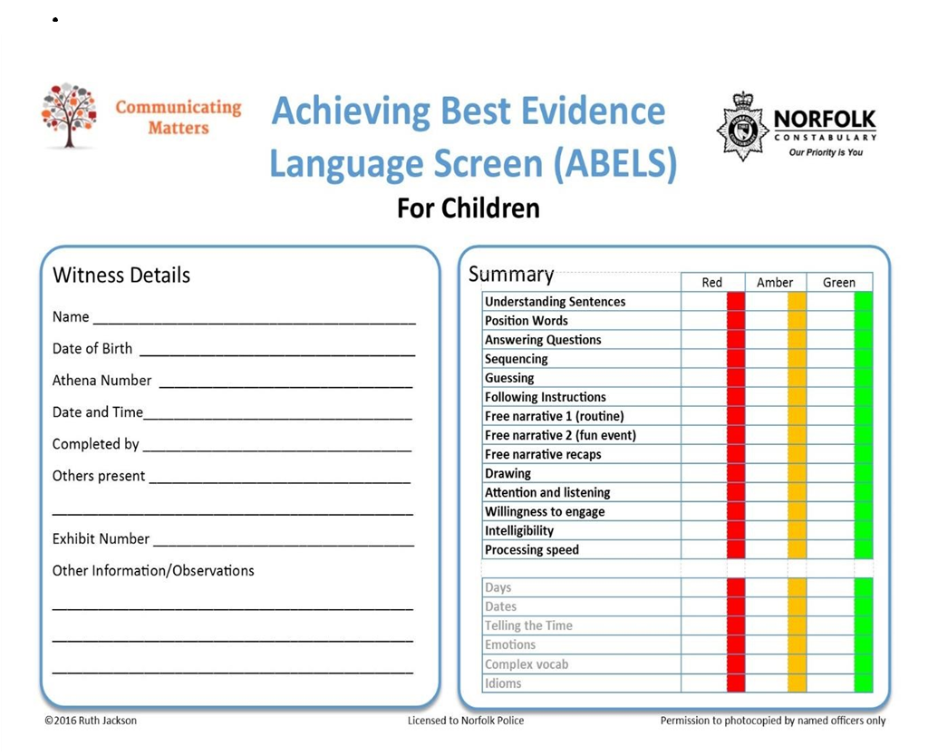
Young person / adult ABELS

This 3-part staged screen identifies young people and adults who mask or hide their communication difficulties. It should also be used for those with recognised needs.

This screen can be used in child abuse investigations including CSE. It can also assist professionals understand the needs of parents/carers who are subject to a criminal investigation or child protection/child in need/child planning.

ABELS scoring sheets are colour coded red, amber and green. This helps investigators clearly see the communication needs of the child, young person, or adult.
ABELS is licenced and can only be used by professionals who have attended training. ABELS is subject to copyright. Though the ABELS screen and Crib Sheet are for any investigating professional to use.
ABELS CRIB Sheet
ABELS Pre-Screen Questionnaire

The Use of Intermediaries
If a police officer and a social worker identifies via an ABELS assessment that a child’s communication might benefit from the use of an intermediary (whether this is due to the child’s age or level of understanding), the intermediary can assess the witness/victim and help the police officer and social worker plan the best means of communicating in the ABE recorded interview. In the case where no ABELS trained officer is available, police and Social Worker can use the ABELS screening tool to gain an initial understanding into the child’s level of understanding and communication.

The intermediary should then write a report for court enabling the trial judge to set ground rules with the advocates on how to question the witness.

Intermediaries are to be considered for every child under the age of 10. During the informal interview stage, the police officer and social worker will assess how able the child is to understand and respond to questioning and to cope with the process of formal interview.

In addition, it is also an opportunity for both police officer and social worker to actively consider if one or other has the necessary skills to guide the child through the interview. If during this interview phase it is assessed that the child does not require an intermediary at THAT STAGE, both agencies must fully record this. It is of note that it is at the discretion of the police sergeant to refer to an intermediary, although social workers can and should challenge this, if it is felt that a child needs this service due to their level of understanding or vulnerability.

If following an ABE, the case moves forward into the court process, the child WILL BE referred to an intermediary to support them through the case, giving evidence, explaining special measures etc.

Whilst an Intermediary may be required, no investigation should be delayed due to acquiring this resource. Police and Social Care to consider who else is best placed to offer support within the child’s family, community, or Social Care as appropriate until the Intermediary can be allocated to the child.

Strategy Meeting/Discussion
When it has been decided that a joint investigation will be undertaken, the CYPS Social Care Practice Manager/Consultant Social Worker and the relevant Safeguarding Investigation Unit (SIU) Detective Sergeant/Detective Inspector will plan the investigation and agree timescales and staff.

Formal recording of the strategy meeting will be the responsibility of CYPS on the designated electronic database. For Complex cases, this will be completed by the County Safeguarding Manager and for non- complex cases this will be completed by the Team Manager/Consultant Social Worker.

The aim of the meeting/discussion is to agree objectives and individual roles within the investigation. The focus of the discussion is to make decisions on how the investigation will proceed.

All investigations must be carefully planned and recorded, even in urgent situations. The discussion may be by way of a meeting for complex cases with the involvement of appropriate line managers and the County Safeguarding Manager or when the referral is straightforward and non-complex, the discussion can be by telephone between the two agencies and the operational team Social Care Practice Manager.

The outcome of the meeting/ discussion will be recorded to include:
- Decisions taken.
- Reasons for decisions.
- Identification of roles.
- Timescales and contingency plan.

If the allegation concerns multiple victim abuse, organised abuse, or abuse in a residential setting, then a strategy meeting must be held, and Chaired by a Safeguarding Manager as required under the SSP Policies and Procedures. The allegations may be clear at the outset or may emerge during the investigation. The meetings will be minuted as open to disclosure in criminal proceedings.

Timing of Investigations/Enquiries
The following referrals may require immediate protective action. These referrals require an urgent response, and the child must be seen to assess their immediate safety and welfare on the day of referral:
- Severe neglect.
- Serious physical injury or threat of physical injury.
- Allegation of sexual abuse where there is a risk of further abuse.

NB – The criteria for enquiries at this stage is ‘reasonable cause to suspect’ and discussions in respect of these 3 categories should be made with this in mind.

Whilst every effort should be made to consult with other relevant professionals before visiting a child, investigations should not be delayed if those staff are unavailable.

Where referrals are received after 5pm careful consideration should be given to whether an evening/ night visit should be made if this would involve waking up the child(ren). In most cases this would be inappropriate, but again the safety of the child(ren) must be the overriding consideration.

Where referrals are received which are not life-threatening and require assessment, the timescales outlined above may not apply. However, it is expected that a child should be seen as soon as possible to assess the child’s safety and welfare.

Any Video Recorded Interview of the child should take place as soon as possible. Any delay in the interview should only be in the interests of the child and the reasons recorded.

Medical Assessment
See Child Protection Medical Assessment Guidance available on the Suffolk Safeguarding Partnership website.

In most cases this should be after the Video Recorded Interview (VRI) has taken place.

Planning the Interview – Stage Two

The Investigative Interview
Planning the actual interview with the child must be done by way of a meeting between the two investigating professionals. This should not be done over the telephone. In circumstances where this is not possible exceptions to alternative ways for conversation are accepted.

Main principles:
- All interviews will be undertaken in accordance with the Achieving Best Evidence in Criminal Proceedings Guidance.
- The interview will normally be recorded by way of a DVD recording or a written statement having regard to the age and understanding of the child.
- The interview plan will be captured in the VRI Planning and Preparation book for interviews with children and any special needs of the child will be identified in this record.
- The investigating professionals will carefully plan the interview by determining for example:
- The child’s developmental level.
- Who should lead the interview.
- Who else might be present:
i)Right 2 of the Statutory Code of Practice for Victims of Crime (Ministry of Justice, 2020) makes it clear that victims have the right to bring a person of their choice to the interview unless that is not possible, in which case victims should be told why.
* (P.66, Achieving best evidence in criminal proceeding guidance)
Supporters must however, be clearly told that their role is limited to providing emotional support and that they must not prompt or speak for the witness, especially on any matters relevant to the investigation,

Video Recorded Interviews
- The child has the ability to engage in an interview; and
- the child has the ability to give evidence in court; and
- clear verbal disclosure of abuse from a child; or
- one child is implicated by another witness as a victim of abuse: or
- there are substantial grounds for suspecting abuse has occurred.

* MoJ Victims Code 2020 (justice.gov.uk)

To establish these criteria, it will normally be necessary to have a short assessment with the child. The purpose of this is to:
- Establish whether a child has anything to say about the allegation or suspicions that led to the referral.
- Make arrangements for the investigative interview which will be the most appropriate for the child. Significant time delays should be avoided.
- The level of rapport that has been established between the child and investigating professionals could help to determine who takes the lead in the ABE interview. In cases of children who are already open to Social Care, the allocated social worker, if ABE trained, is likely to have built up rapport and understanding of the child.

Further information on the planning for child witnesses see paragraphs 2.34 to 2.77 in the Judicial guidance.

The pre-interview assessment should never replace or overshadow the substantive interview with the child and should aim to complete the ABELS screen or needs assessment as well as a potential clarification conversation.

It is important not to coach the child in respect of any subsequent interviews.

However, it is an opportunity to assess the appropriateness of recording the interview to assess the child’s willingness to be interviewed on DVD and to answer his/her questions about the reasons for the interview.

The assessment interview with the child should, as far as possible, adhere to the following basic principles:

- Listen to the child. Any question directed to the child at this stage must be in accordance with ABE guidelines.
- Never stop a child who is freely recalling significant events.
- Needs assessment or ABELS screen to be completed, and interview question styles to be trialled in the process.
- An accurate and detailed record of a discussion must be made. If the discussion includes a disclosure of abuse, that part must be recorded verbatim and contemporaneously or, at the very least, as soon as possible after the contact. Notes should be made on the joint investigation forms or in the Police Officer’s notebook. Times and persons present should be included.
- Record all subsequent events up to the time of the substantive interview.
- Even if no disclosure of a potential criminal offence is made, accurate recording is essential as decisions about risk may be made on the strength of them.
- If there are concerns in respect of other siblings in the household, the issue of contamination of evidence will need to be addressed.

When not to undertake a DVD Interview
- Indirect suspicions or anonymous allegations.
- When the employment of DVD equipment may be abusive (i.e. DVD/videos used in the abusing behaviour).
- Solely for civil proceedings.

Before embarking on a VRI of a child under five years of age, authority must be sought from Detective Inspector/Detective Sergeant in the Child Abuse Investigation Unit and the Service Manager in Children’s Services. This authority must be recorded.

There is also a requirement to consult the CYPS if there is an intention to re-interview a child victim as part of a criminal investigation.

When to Consult Experts, Interpreters, and/or Intermediaries

For Children with Disabilities
The term ‘children with disabilities’ encompasses a wide range of impairments of varying severity. There is rarely any reason in principle why children with disabilities should not take part in a video recorded investigative interview provided the interview is carefully tailored to the particular needs and circumstances of the child seeking specialist advice where needed.

Specialist workers are those with particular areas of expertise in working with children with disabilities and will include some social workers, speech and language therapists, occupational therapists, psychologists and psychiatrists and registered intermediaries.

It will be necessary to consult with experts to agree what, if any, role they should take during the DVD interview in the following circumstances:
- The child’s first language is not English.
- The child has a mental disorder/is psychologically disturbed.
- The child has a disability or a sensory impairment.
- Members of the team do not have sufficient knowledge and understanding of the child’s racial, religious, or cultural background.
- Where unusual forms of abuse are suspected.

Consent of the Child
Where the child has sufficient understanding, consent must always be obtained from the child and to enable consent to be given, adequate information must be given regarding the purpose of the interview. Refusal of consent must be respected however consent is not necessary from the child (although it unlikely to be practicable or desirable to record an interview with a reluctant or hostile child).

Where a recording is to be made the child must be informed about who may see the interview recording. Following the interview, if it is apparent that a criminal prosecution may follow and that the child will be required as a witness, then both the child and appropriate carers should be fully informed of the implications of such a course of action. At no point must a child, parent(s) or carer(s) be led to believe that the Court will not require the child’s oral evidence.

Parent/ Carer Involvement
In the majority of investigations, it is expected that concerns will be shared with the parents/ carers before the child is seen. as a rule, information should be shared with parents/carers unless to do so would affect the safety and welfare of the child or other children or be detrimental to the criminal investigation. If a decision is made not to inform the parents/ carer the reasons must be recorded. The needs and safety of the child must be the first consideration when determining at what point parents/ carers should be informed of concerns. The child should never be interviewed in the presence of an alleged or suspected perpetrator.

Unless the child has sufficient understanding to agree to being interviewed in his/her own right the agreement of a:
- Parent or
- Person with parental responsibility or
- Authorisation by a court is required.

The investigating team may need to interview a suspected child victim without the knowledge of the parent or carer in certain situations. This might include the possibility that a child would be threatened or otherwise coerced into silence; a strong likelihood that important evidence would be destroyed; or that the child in question did not wish the parent to be involved at that stage, and is competent to take that decision, (see ‘Working Together’ paragraph 5.34). In all cases where the Police are involved, the decision about when to inform the parent or carer will have a bearing on the conduct of the Police investigation, and the strategy discussion should decide on the most appropriate timing of parental participation.

It is not good practice, from an evidential perspective, for a parent to be allowed in an interview or in the monitoring room particularly if the parent has taken disclosure from the child.

Conducting the interview stage 2.1

The overall purpose of an interview with a witness or victim is to obtain an accurate and reliable account in a way that is fair, is in the witness’s interests and is acceptable to the court. Over the years, many professionals have recommended the use of a phased approach of interviewing that starts with a free-narrative account before gradually becoming more and more specific in the nature of the questioning in order to elicit further detail. The approach recommended in this guidance consists of the following four phases:

- Rapport.
- Free-narrative account.
3(a) Topic division followed by clarification and development of the account.
3(b) Systematic introduction and probing of any wider investigative material that may be important to the investigation.
4 Closure.

Typical Interview Structure:
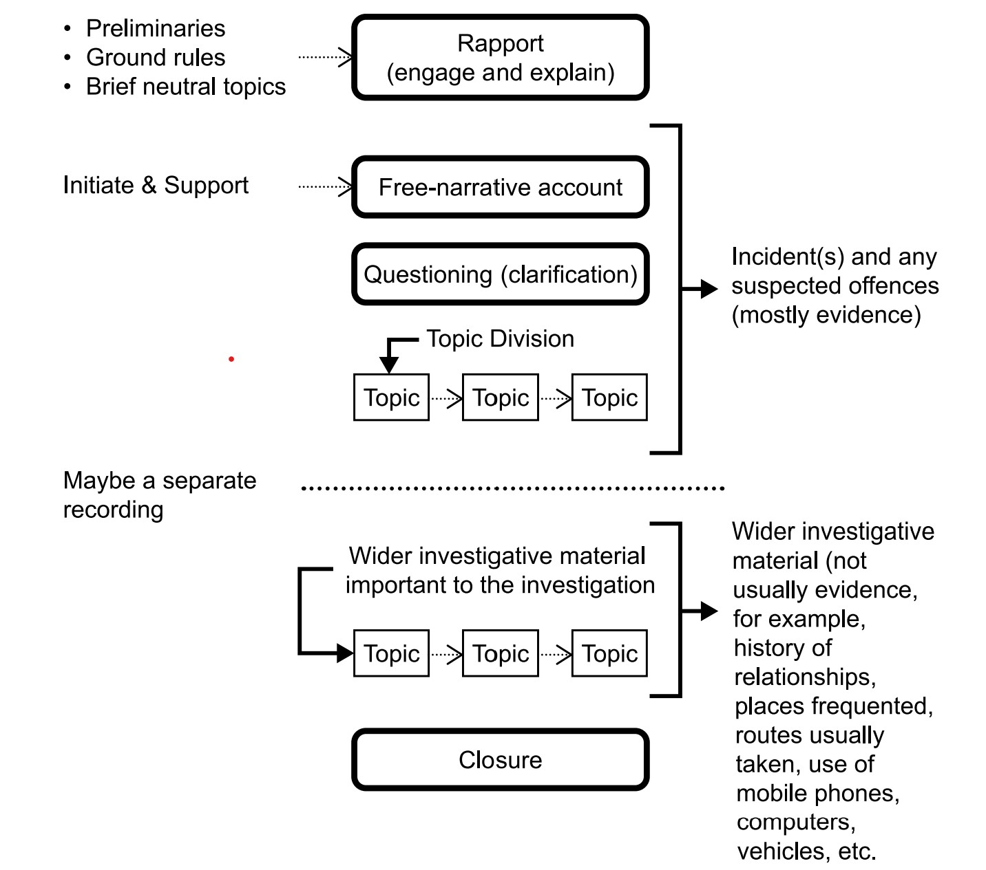

Viewing the DVD Interview
It is good practice for Social Workers & Police Officers to view their DVD after the interview and again before the court case. This responsibility also rests with the line managers.

The Child Who Becomes a Suspect
Children who are being interviewed as witnesses may make a statement during the interview that implies, they are also abusers or disclose they have committed other crimes. If a child victim appears to be a suspect during an interview, a decision will have to be made on whether to proceed or terminate the interview. The interviewers should take a short break to consult on the matter.

If it is concluded that the evidence of the child as suspect is paramount in a particular case, the interview should be terminated so that any further questioning can be carried out in accordance with the Police and Criminal Evidence Act 1984 guidance. (This may occur when dealing with an older child).

A short debriefing between the interviewers will take place to evaluate information and evidence obtained. This debriefing may also involve line managers.

Following the Interview – Stage Three

Medical Assessment – see Joint Paediatric Protocol

2.61 Medical examinations should only be contemplated if they are strictly necessary for the purpose of the criminal proceedings. Where they are necessary, the number of examinations should be kept to a minimum (Right 2 of the statutory Code of Practice for Victims of Crime, Ministry of Justice, 2020). The advice of the CPS should be sought at the earliest opportunity in cases where there is any doubt about the need for a medical examination.

Immediate Action
Immediate decisions will need to be made in consultation with the responsible CYPS Practice Manager/Consultant Social Worker, the Social Worker, and the Police SIU Investigator.

The following are considerations and are not exhaustive:
- What action is necessary for the immediate protection of the child based on a risk assessment.
- Whether or not to interview other children in the household.
- What immediate support the child and family require.
- What issues of ethnicity race, religion, culture, gender, or disability are raised in the case, how and by whom they are to be addressed and what advice needs to be sought.
- Any legal action which may need to be taken and by whom.
- What further information is required and who will obtain this.
- What action, if any, is necessary to avoid the subject of the interview talking to other suspected witnesses before their interview is conducted

Decisions will be recorded utilising the Police SIU database and the ‘strategy discussion’ form on the Children and Young People’s Services electronic recording system.

Assessment of Risk
A decision must be made on whether the child is safe to remain at home or return home. Some exploration of the following issues must be made at the investigative stage:
- Seriousness of any injury/abuse.
- Is the abuse current?
- Previous injuries/abuse.
- Availability of a protective person – have they demonstrated a willingness/ability to protect?
- Any history of family violence?
- Any history of abnormal parent/ child attachment?
- History of drug abuse, alcohol abuse or mental illness.
- What supportive networks are available?
- Can the child take action to protect him/herself, (e.g. if an older child, or is the child afraid to return home)?

There may be other relevant factors to consider in compiling assessment of risk – these are not exhaustive. It is important that the child’s views are taken into consideration and recorded. It is also important to be mindful of pressures to which children may be subjected.

Longer Term Planning
Some investigations will go on to an initial child protection conference, which will consider whether:
- The threshold criteria for ‘significant harm’ has been met.
- Any necessary legal action to protect the child.
- The child and family’s therapeutic needs.

The following issues will need to be addressed if criminal proceedings take place:

- Involving the child in the decision-making process – informing him/her that the DVD will be played in court and they will be cross-examined, obtaining the child’s consent to do this.
- Preparation for the child for court. Enabling the child to view the DVD to refresh their memory.
- Guidance to the child and carers on the court process.
- Identification of the responsible adult in relation to child witness pack.

Monitoring and Reviewing Arrangements
There will be regular meetings between Police and Children’s Services to monitor arrangements contained within the Protocol.

